

KENT PARK PRIMARY SCHOOL
2019

Kindness – Respect - Responsibility

Nº 11. TERM THREE Thursday 25th July 2019

Monday 29th July Y5/6 Knox Division Football
Wednesday 31st July Y3/4 Hooptime
Thursday 1st August BOOKCLUB Orders due.
Friday 9th August Y5/6 Hooptime
Monday 12th August School Council Meeting – 7.00pm in Staffroom (6.45pm Sub-Committees)
Sunday 18th August KPPS Working Bee 9am-12noon (with ‘secret treat’ cooked on BBQ by Mr Denver’).
Mon-Fri 16th-20th September Y6 Camp – Coonawarra Farm Resort, Glenaladale
Wednesday 18th September Y3 Edendale Farm Excursion
Wed-Fri 16th-18th October Y4 Camp – Phillip Island

** We recommend checking COMPASS weekly on a Sunday evening
to ensure consent/payment deadlines are met.
_________________________________________________________________________________

Farewell to Bianca Esplin who is transferring to Montrose Primary School.
From the Principal
Welcome Back!
It certainly seems like everyone has come back from our mid-year break refreshed and ready-to-go and we have made a terrific start to term 3!
Term 3 is a really important term for our student leadership teams across the school. As our established grade 6 team begin preparations for Secondary College both our grade 4 and 5 teams start to prepare for stepping up into their leadership roles for 2020. As many of our senior students already know, we expect all our students in grade 5 and 6, whether they have a badge or not, to rise to the responsibility of leading our school and demonstrating our school values at all times.
A special welcome to our 6 new international students, Sophia, Toby, Prince, Sky, Jeremy and Michael. We hope you enjoy your time in Australia and your time at KPPS.
Welcome back also to some of our staff for term 3….Mrs Nacha, Mr Martin and Mrs Burns.

Grade 3 camp
To be greeted by the bus driver saying to me as the bus pulled up after our grade 3 camp this week ‘these are the best kids I’ve ever taken to and from a camp’ would have to be one of the nicest things a Principal can hear. I then proceeded to help the bus driver unload the luggage and had many of our awesome grade 3 students pitching in to help…. Simply Amazing!!!!!! All of our wonderful staff attending the camp also agreed that our grade 3 students were fantastic and everyone enjoyed their first school camp. Congratulations grade 3’s!!!!

PA Team
Congratulations to our amazing PA team on another successful fund raising event at our recent trivia night. The new technology we purchased last week with some of the funds raised has already started making its way into the classrooms and we have some very excited students and staff, particularly in 6S.
A little reminder from our PA team…. if you have a Rebel Sports card or you are purchasing items from any Rebel store, make sure you either register your card or mention Kent Park as your local school and we will continue to receive equipment for our school.

Working Bee
Boy do we need a tidy up!
With all of the wet and windy weather our school grounds are in desperate need of a tidy-up as well as a few other small projects around the school. Our next working bee is scheduled for Sunday August 18th from 9-12. Followed by our increasingly-famous and top-secret bbq delicacy… yum-scrum-bubblegum!

Prep 2020 Transition Program
Next week we will be sending out all of the important information to our new 2020 Prep families including the dates and activities for our Prep Transition Program. At this stage of the year, we have more Prep enrolments than last year so it’s important for any families that haven’t submitted their enrolment forms to get them back to us soon.
Here are our dates for this year:
Term 3 (Play Dates - for all interested families either enrolled or interested in enrolling)
- Thursday August 29th, 2.30-3.30 (our Fathers’ Day Stall will be open during this session)
- Tuesday September 3rd, 2.30-3.30.
Term 4 (Structured Transition Program)
- Thursday October 24th, 9.15-11am
- Friday November 8th, 2.30-3.30pm
- Thursday November 28th, 9.15-11am
- Tuesday December 10th, 2.30-3.30pm

2019 ‘OFFICIAL’ Parent Opinion Survey
We Want Our Parents To Tell Us What They Think!
Our school is conducting a survey to find out what parents think of our school. The Parent Opinion Survey is an annual survey offered by the Department of Education and Training that is conducted amongst a sample of randomly selected parents. It is designed to assist schools in gaining an understanding of parents’ perceptions of school climate, student behaviour and student engagement. Our school will use the survey results to help inform and direct future school planning and improvement strategies.
Approximately 30 per cent of parents will be invited to participate in this year’s survey. All responses to the survey are anonymous. This year the Parent Opinion Survey will be conducted from Monday 22rd July to Sunday 11th August.
The survey will be conducted online, only takes 10-15 minutes to complete, and can be accessed at any convenient time within the fieldwork period on desktop computers, laptops, tablets or smartphones. The online survey will be available in a range of languages other than English. These include: Arabic, Vietnamese, Mandarin, Chin (hakha), Hindi, Japanese, Somali, Turkish, Punjabi and Greek.
2019 ‘UNOFFICIAL’ Parent Opinion Survey
The WHAT?????
That’s right, this year we are offering an ‘Unofficial’ Parent Survey. We’ve printed a copy of the official survey and photocopied enough for every Kent Park family to complete.
WHY have we done this???
We know some families have never been selected in the random sample before and we thought this could be a good way to give everyone the opportunity to respond. We’re also really interested in hearing from everyone in our community, particularly after all of the improvements we’ve made in the last 12 months. Just fill in the survey and return it to either the office or the classroom in the envelope supplied. All survey responses will remain anonymous and will be collated by representatives from our school council. The results from this survey cannot be merged with the official survey results, but we look forward to comparing the two different approaches.

Kieran Denver

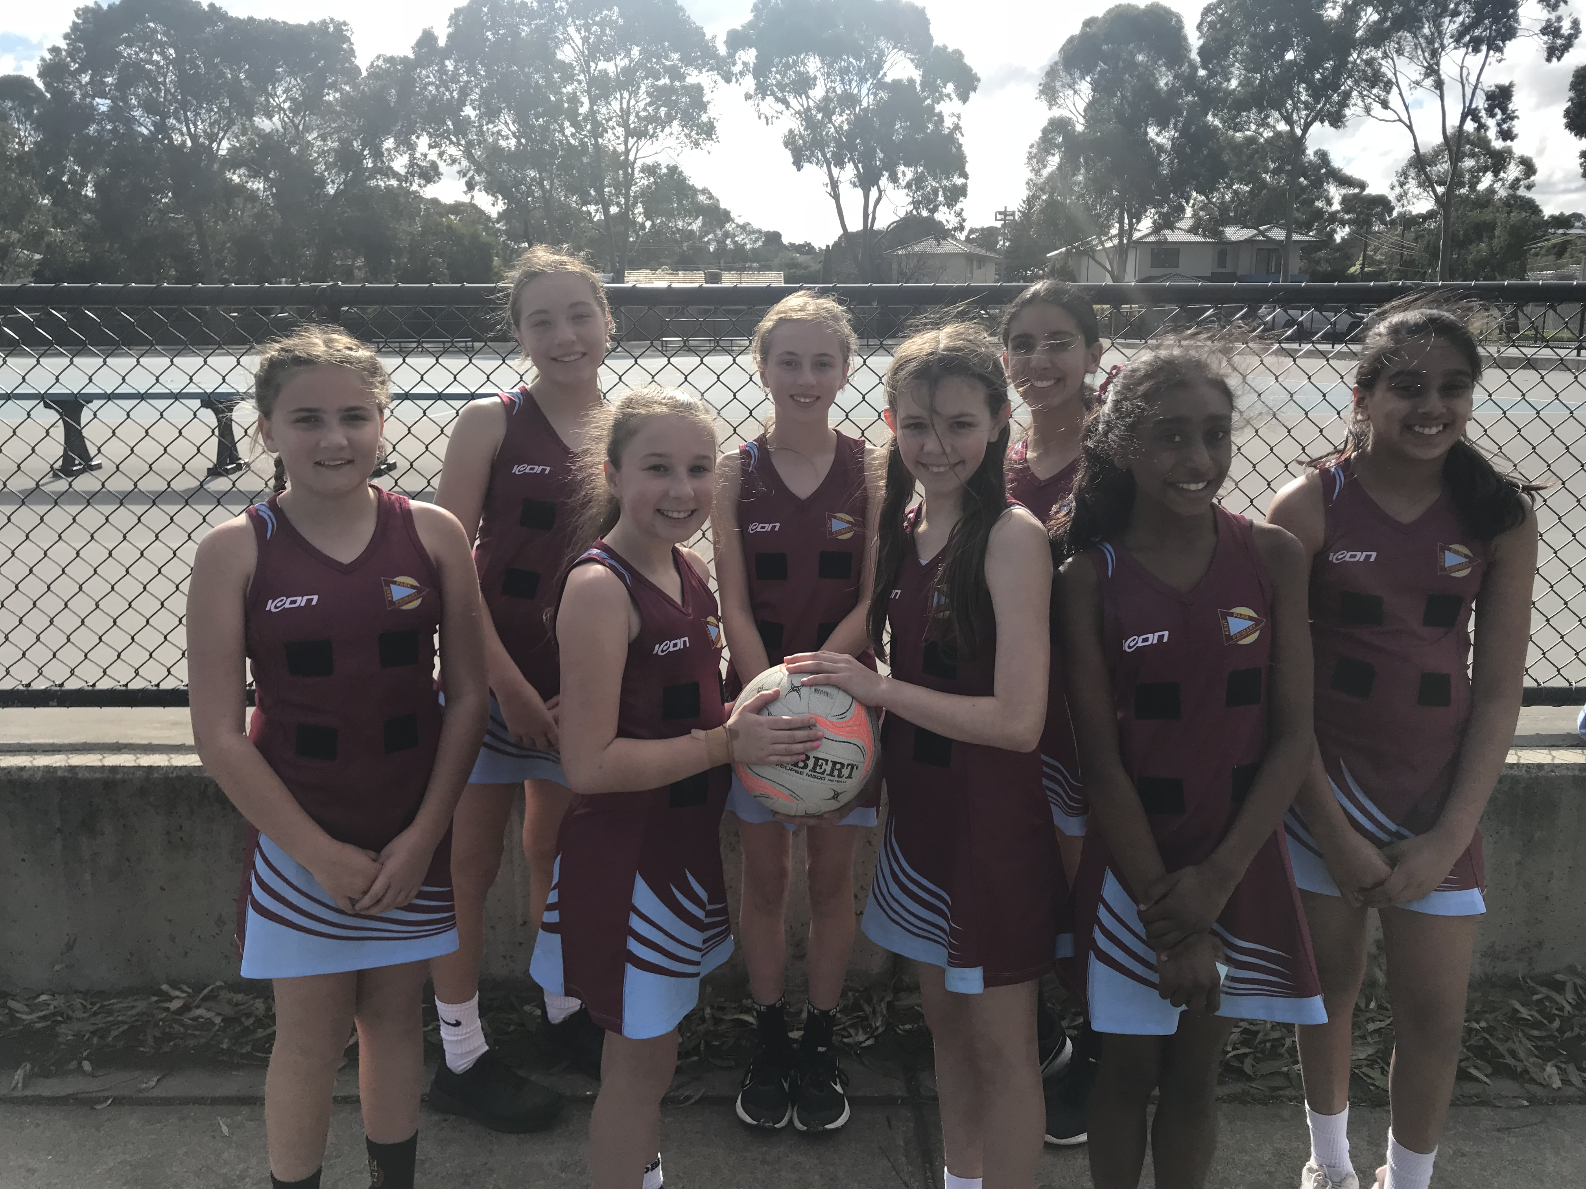
NETBALL REPORT
On Tuesday, the Netball A team represented Kent Park as the District Champions and competed at the Knox Regional Netball Centre.
We played three really competitive games, winning one and losing two and made it into our round finals after beating Wantirna. In the final, we thrashed Mountain Gate, 18-3. Our defenders were intercepting machines, the centre court players sped around some opposition giants and our shooters were raining goals.
We are all proud of each other and what we achieved. Thank you to everyone who helped out.
Grace Bird and Vaidehi Kerai

Weekly Merit Awards for Week Beginning 15th July, 2019
Class | Student | Reason
PW | Ben H. | For reading with great fluency and expression and for always helping others.
P/1H | Steele B. | For a great attitude this week and trying his best! Super effort.
1/2H | Emily W. | For her outstanding presentation on Canada. You’re a star!
2B | Emily S. | For making a fabulous effort to pay attention to the success criteria with her reading responses.
3K | Addison C. | For being kind and helpful to our visiting Chinese students.
3M | Jaxon K. | For contributing so enthusiastically to our class discussions. Thank you.
4C | Sofia F. | For being a great role model for our international students.
4/5C | Jackson B. | For his cheerful, positive attitude to all aspects of school.
5B | Jake D. | For having a fantastic attitude and completing tasks to a great standard.
6K | Cooper G. | For consistently displaying a confident approach to his schoolwork. Well done.
6M | Pareena V. | For being an amazingly helpful classroom member. Keep it up!
6S | Lily E. | For beginning Term 3 by putting a huge effort into her learning.
Phys. Ed. | Willow C. | For your sensational effort during Phys. Ed. this week.
STEAM | Zyuri A. | For your persistence with our Steam task this week.
ART | Simone C. | For her amazing effort in creating a self-portrait. Well done Simone!
Asst. Prin. | Cooper G. | For demonstrating the school value of ‘kindness’ throughout the week. Kate loves her scarf!
PRINCIPAL | Ethan Z.  Ian Z.  Emily W. | For being a great helper for our international students.  For being a great helper for our international students.  For being a great helper for our international students.

Weekly Merit Awards for Week Beginning 22nd July, 2019
Class | Student | Reason
PW | Corey W. | For trying his best to write his name and writing the letter ‘g’. Well done.
P/1H | Sophie O’B. | For trying her best with her work and making great choices with her learning.
2B | Lucy B. | For her amazing effort following Buzzy around Europe.
3K | All of 3K  Milla S. | For demonstrating Kindness, Respect and Responsibility on camp.  For being environmentally responsible and picking up papers without being asked on Camp.
3M | All of 3M | For being Kind, Respectful and Responsible Campers.
4C | Nawat W. | For his enthusiasm during our Polly Woodside excursion.
4/5C | Dale J. | For listening attentively and asking thoughtful questions.
5B | Ali C. | For her positivity and inclusive attitude in the classroom.
6K | Alex K. | For demonstrating outstanding work habits. Well done Alex!
6M | Lincoln M. | For the outstanding enthusiasm you have shown in class this term.
6S | Tyler M. | For managing his time so much better in class.
Phys. Ed. | Ryan Q. | For your excellent effort during Phys. Ed. lesson this week.
STEAM | Caleb L. | For the great job you did constructing your rocket during STEAM.
Asst. Prin. | All of the Prep Students | For an amazing first 100 days of school. You are all super stars!
PRINCIPAL | All of our Grade 3 Campers | For being amazing campers. We are very proud of all of you!



